VISVESVARAYA TECHNOLOGICAL UNIVERSITY
“JNANA SANGAMA” , BELAGAVI-590018, KARNATAKA


S
“AICTE ACTIVITY REPORT”
Submitted in the partial fulfillment of the requirement for the award of degree of

BACHELOR OF ENGINEERING
in
COMPUTER SCIENCE & ENGINEERING
Submitted By

Sainath 1VA22CS106

Under the Guidance of

Dr. Ajay V G Prof. Anila Davis
AICTE Activity Point Program Coordinator AICTE Activity Point Program Coordinator
Dept of CSE Dept of CSE
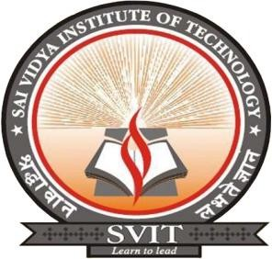

DEPARTMENT OF COMPUTER SCIENCE & ENGINEERING

SAI VIDYA INSTITUTE OF TECHNOLOGY
(Affiliated to Visvesvaraya Technological University, Belagavi | Recognized by Govt. of Karnataka | Approved by AICTE, New Delhi)
Accredited by NBA, New Delhi (CSE, ISE, ECE), NAAC – “A” Grade
RAJANUKUNTE, BENGALURU – 560 064
2025-26

SAI VIDYA INSTITUTE OF TECHNOLOGY
(Affiliated to Visvesvaraya Technological University, Belagavi | Recognized by Govt. of Karnataka | Approved by AICTE, New Delhi)
Accredited by NBA, New Delhi (CSE, ISE, ECE), NAAC – “A” Grade
Rajanukunte, Bengaluru- 560 064

DEPARTMENT OF COMPUTER SCIENCE & ENGINEERING


CERTIFICATE

This is to certify that the Activity work entitled “AICTE ACTIVITY POINTS PROGRAMME” carried out at Rajanukunte by Mr. Sainath (1VA22CS106), a Bonafide students of SAI VIDYA INSTITUTE OF TECHNOLOGY, Bengaluru, under “AICTE ACTIVITY POINTS PROGRAMME” in
partial fulfillment for the award of Bachelor of Engineering in Computer Science & Engineering of VISVESVARAYA TECHNOLOGICAL UNIVERSITY, Belagavi during the year 2025-26. The Activity report has been approved as it satisfies the university requirements in respect of Activity work points prescribed for the said Degree.

Dr. Ajay V G
AICTE Activity Point Coordinator Dept. of CSE, SVIT
Dr. Shashikumar D R Professor & Head Dept. of CSE, SVIT

Prof. Anila Davis
AICTE Activity Point Coordinator, SVIT
Dr. Manjunath T N
Principal, SVIT

The completion of AICTE Activity Points Programme brings with and sense of satisfaction, but it is never completed without thanking the persons who are all responsible for its successful completion. First and foremost, I wish to express our deep sincere feelings of gratitude to my Institution, Sai Vidya Institute of Technology, for providing mean opportunity to do our education.
I would like to thank the Management and Prof. M R Holla, Director, Sai Vidya Institute of Technology for providing the facilities.
I extend my deep sense of sincere gratitude to Dr. Manjunath T N, Principal, Sai Vidya Institute of Technology, Bengaluru, for having permitted to carry out the activity work on “AICTE ACTIVITY POINTS PROGRAMME” successfully.
I am thankful to Prof. A M Padma Reddy, Additional Director and Professor, Department of Computer Science and Engineering, Sai Vidya Institute of Technology, for his constant support and motivation.
I express my heartfelt sincere gratitude to Dr. Shashikumar D R, Professor & Head, Department of Computer Science & Engineering, Sai Vidya Institute of Technology, Bengaluru, for his valuable suggestions and support.
I express my sincere gratitude to Dr. Ajay V G, Associate Professor, Department of Computer Science & Engineering, Sai Vidya Institute of Technology, Bengaluru, for his constant support.

I express my thanks to Prof. Anila Davis, Assistant Professor, Department of Computer Science & Engineering, Sai Vidya Institute of Technology, Bengaluru, for her valuable suggestions and support.
Finally, I would like to thank all the Teaching, Technical faculty and supporting staff members of Department of Computer Science & Engineering, Sai Vidya Institute of Technology, Bengaluru, for their support.

Sainath 1VA22CS106

ABSTRACT

The AICTE Activity Points Programme serves as a vital component of the Bachelor of Engineering curriculum under Visvesvaraya Technological University (VTU), aimed at fostering social responsibility and holistic student development. This report details the community service interventions undertaken to accumulate the requisite activity points for degree eligibility. The primary objective was to identify societal challenges and implement sustainable, localized solutions through community engagement. Fieldwork was conducted across three distinct urban and peri-urban locales in Bengaluru: Indiranagar, Yelahanka, and Singanayakahalli. These locations offered a diverse demographic mix, allowing for a comprehensive study of infrastructure gaps and public awareness levels regarding civic sustainability.
The project focused on five key pillars of national development. Under the Digitization of India initiative, workshops were organized to promote digital financial literacy and UPI adoption among small vendors. The Swachh Bharat Abhiyan and Garbage Disposal activities involved cleanliness drives and the installation of segregated waste bins to encourage effective solid waste management. To address resource scarcity, a Sustainable Water Management awareness campaign was launched, focusing on rainwater harvesting techniques suitable for urban dwellings. Furthermore, the Energy Swaraj initiative emphasized the reduction of energy consumption through the "Avoid, Minimize, Generate" framework. These activities collectively enhanced community awareness, promoted civic engagement, and provided practical exposure to tackling real-world engineering and social problems.

ACKNOWLEDGEMENT I
ABSTRACT II
TABLE OF CONTENTS III
LIST OF TABLES V
CHAPTER 1 1
INTRODUCTION 1
CHAPTER 2 4
AICTE ACTIVITIES 4
  - Digitization of India 4
    - Objectives 4
    - Description of event 4
    - Activity Images 5
  - Developing an Efficient Garbage Disposal System 7
    - Objectives 7
    - Description of event 7
    - Activity Images 8
  - Developing Sustainable Water Management 9
    - Objectives 9
    - Description of event 9
    - Activity Images 10
  - Energy Swaraj- Reduction in Energy Consumption 11
    - Objectives 11
    - Description of event 11
    - Activity Images 12
  - National Initiative – Swachh Bharat Abhiyan 13
    - Objectives 13
    - Description of event 13
    - Activity Images 14
CHAPTER 3 15
CERTIFICATES 15
CHAPTER 4 21
CONCLUSION 21

List of Tables
Table 1.1 Activity Summary Sheet 3

CHAPTER 1

INTRODUCTION

The AICTE Activity Point Program is a significant, mandatory reform initiative introduced by the All-India Council for Technical Education (AICTE), the apex regulatory body for technical education in India. The program is founded on the recognition that professional success in the 21st century requires engineers to possess a comprehensive skillset that extends beyond core academic and technical expertise. Therefore, this mechanism was established to integrate extracurricular, co-curricular, and community engagement into the academic structure, mandating student participation to cultivate essential soft skills, leadership qualities, teamwork, entrepreneurial spirit, and a deep-seated sense of societal commitment. By prioritizing holistic development, the AICTE aims to transform students from passive recipients of knowledge into proactive, responsible citizens capable of driving national progress.

This report details the execution and outcomes of student engagement across five core pillars of the AICTE activity mandate, all of which are strategically aligned with national development goals and the United Nations Sustainable Development Goals (SDGs). The five focus areas analyzed include: Digitization of India, which aims to bridge the digital divide by promoting technological literacy and digital financial inclusion among underserved populations; Developing an Efficient Garbage Disposal System, which addresses the critical challenge of urban waste through segregation, recycling, and efficient logistics; Developing a Sustainable Water Management System, which focuses on mitigating water scarcity through rainwater harvesting and conservation technologies; Energy Swaraj - Reduction in Energy Consumption, which emphasizes the "Avoid, Minimize, Generate" framework to foster energy literacy and reduce carbon footprints; and the National Initiative Swachh Bharat Abhiyan, which drives civic action to ensure public health, dignity, and improved sanitation standards in adopted communities.

The implementation of these activities serves a crucial dual purpose. Firstly, it functions as a highly effective experiential learning platform, allowing students to apply theoretical engineering and management principles to solve tangible, real-world problems. For instance, technical students can design automated waste segregation models or conduct energy audits for

local households. Secondly, the program reinforces a culture of data-driven accountability and measurable impact. Every activity—from monitoring reductions in household electricity usage to reporting on community waste management improvements—is tracked and validated. This rigorous process ensures that students not only fulfill the mandatory activity point requirement for the award of their engineering degree but also secure practical, field-based experience, positioning them as ethically conscious and highly capable contributors to India’s sustainable economic and social future.

Table 1.1 Activity Summary Sheet

Name of the program/ Activity Head | Panchayat/ District | Dates/ Total duration | Maximum points/  activity | Remarks
1. Digitization of India | Indiranagar, Bangalore | 03-11-23  to  30-11-23  80 hours | 20 | Accomplished
2. Developing an Efficient Garbage Disposal System | Indiranagar, Bangalore | 02-04-24  to  30-04-24  80 hours | 20 | Accomplished
3. Developing Sustainable Water Management | Rajanukunte, Bangalore | 02-09-24  to  30-09-24  80 hours | 20 | Accomplished
4. Energy Swaraj – Reduction in Energy Consumption | Nagsandra, Bangalore | 02-01-25  to  31-01-25  80 hours | 20 | Accomplished
5. National Initiative –  Swachh Bharat Abhiyan | Indiranagar, Bangalore | 02-08-25  to  31-08-25  80 hours | 20 | Accomplished
TOTAL: 100 points

CHAPTER 2

AICTE ACTIVITIES

2.2 Digitization of India

Objectives
      - To create awareness among small-scale vendors and local shopkeepers about the benefits of digital financial inclusion and the transition towards a cashless economy.

      - To facilitate the technical adoption of the Unified Payments Interface (UPI) by assisting merchants in setting up business accounts and installing digital payment scanners.

      - To educate the unorganized retail sector on the security, transparency, and ease of record-keeping provided by digital transaction methods, thereby bridging the digital divide.

Description of the Event
The Digitization of India initiative is a transformative campaign aimed at empowering society through digital access and financial inclusion. At its core, the move towards a "Digital India" seeks to streamline economic activities by reducing the dependency on physical cash, thereby curbing the circulation of black money and enhancing economic transparency. A critical component of this ecosystem is the Unified Payments Interface (UPI), a real-time payment system that facilitates inter-bank peer-to-peer and person-to-merchant transactions. For small businesses, adopting digital payments is not merely a technological upgrade but a business necessity; it eliminates the recurring issue of exact change, provides an automatic digital ledger of daily sales, and opens avenues for creditworthiness within the formal banking sector. By integrating technology into everyday commerce, the initiative fosters an environment where economic growth is inclusive, efficient, and data-driven, ultimately contributing to the nation's goal of becoming a digitally empowered society and knowledge economy.
The activity began with an orientation session where students were trained on the various merchant applications available (such as BHIM, Google Pay for Business, and PhonePe) and the necessary Know Your Customer (KYC) documentation required for onboarding. Equipped

with this technical knowledge, the student volunteers visited local marketplaces and identified small vendors—ranging from vegetable sellers to stationery shop owners—who were still operating exclusively on cash. The students engaged with these merchants, explaining the long- term benefits of digital payments, addressing their apprehensions regarding security, and demonstrating the ease of use. The core of the activity involved hands-on assistance: students helped the shopkeepers download the relevant merchant apps, link their bank accounts, and successfully generate their unique QR codes. Furthermore, assistance was provided in ordering or printing physical QR code scanners/standees for their counters. The event was highly impactful, as it resulted in the immediate digital onboarding of several local businesses, turning engineering students into active agents of technological change who successfully bridged the gap between complex banking technology and the everyday needs of the common citizen.

Activity Images

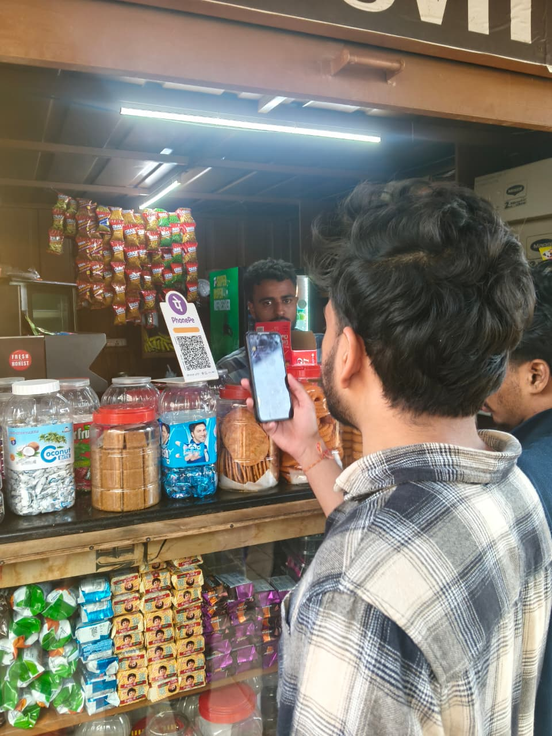

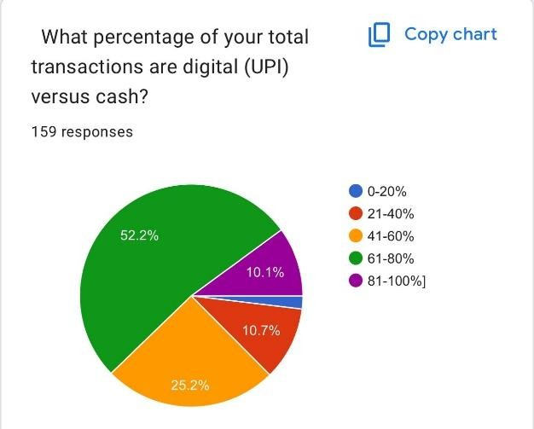

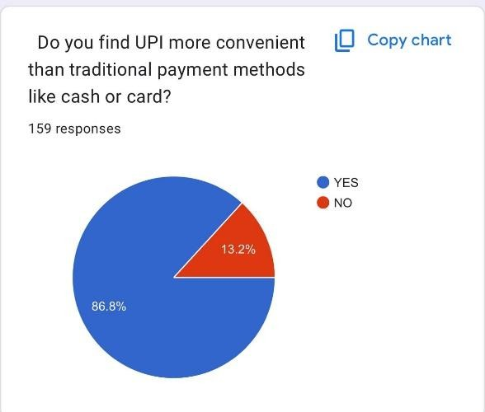

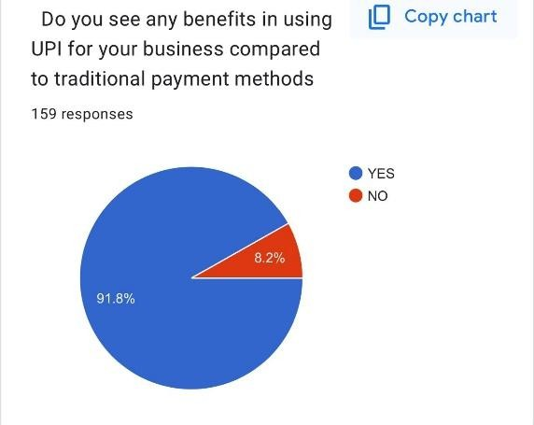
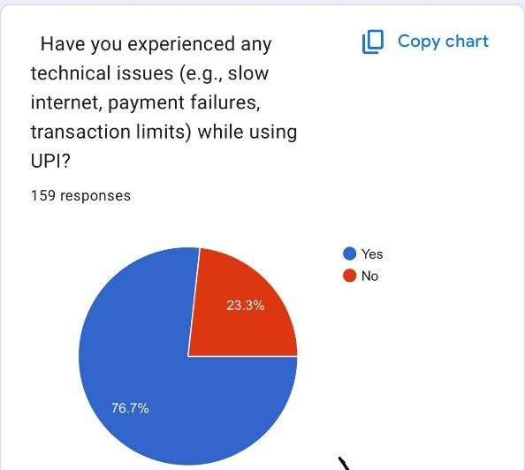

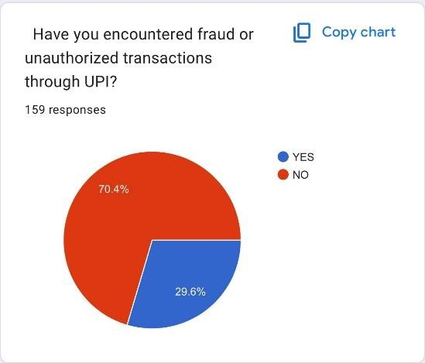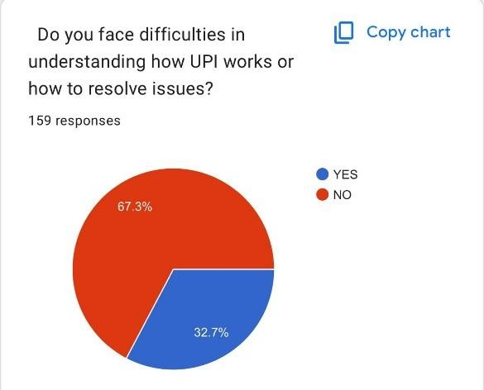

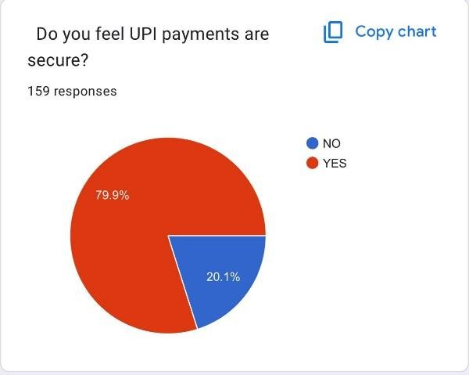
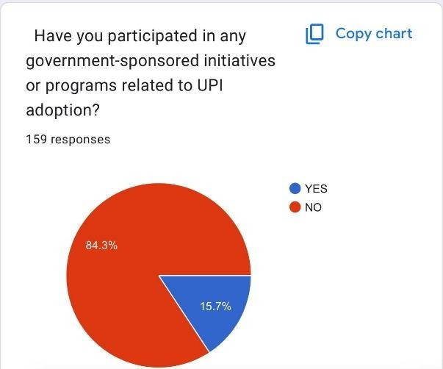
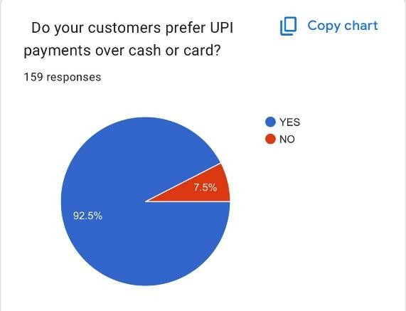
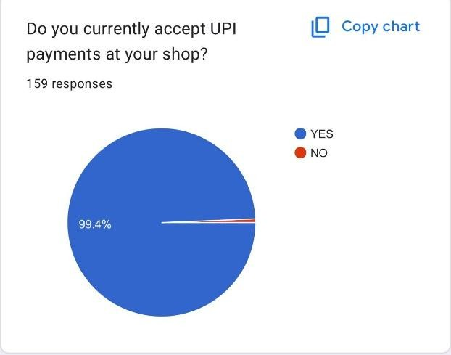

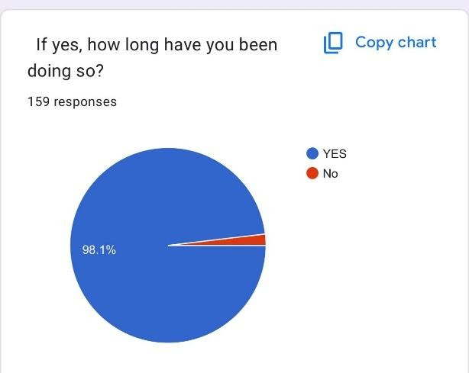

Developing an Efficient Garbage Disposal System

Objectives
      - To install a sense of civic responsibility among students regarding urban sanitation and the maintenance of public recreational spaces.

      - To execute a practical demonstration of 'source segregation,' categorizing waste into plastic, glass, and paper to facilitate effective recycling and resource recovery.

      - To mitigate environmental pollution in local green zones by removing non- biodegradable waste that threatens local flora and fauna, thereby improving the ecological quality of the park.

Description of the Event
Efficient garbage disposal is a critical component of sustainable urban living and constitutes the backbone of modern waste management strategies. It transcends the simple act of collection, focusing heavily on the categorization of waste streams to maximize resource recovery and minimize landfill usage. The scientific rationale behind this approach lies in the "Waste Hierarchy"—Reduce, Reuse, and Recycle. Mixed waste, often referred to as municipal solid waste, poses severe environmental hazards as it contaminates soil and groundwater while generating harmful greenhouse gases during decomposition. By strictly segregating waste into specific categories such as Plastic (petroleum-based polymers that take centuries to decompose), Glass (which is 100% recyclable but dangerous if broken), and Paper (biodegradable but resource-intensive to produce), communities can ensure that materials re- enter the production cycle. This process of source segregation not only reduces the ecological footprint of urbanization but also transforms waste from a burden into a valuable resource, supporting the circular economy and ensuring safer public spaces for the community.
The practical implementation of this initiative was conducted at a public park in Indiranagar, Bangalore, a vital green lung in a dense urban setting. The activity began with a briefing on safety protocols, including the importance of wearing gloves and using proper tools for handling potentially hazardous debris. Students and volunteers systematically canvassed the park, collecting scattered litter that had accumulated in bushes, walkways, and seating areas.

The core of the activity, however, was the rigorous segregation process. A designated sorting station was established where the collected waste was separated into three distinct streams: Plastic (bottles, wrappers, and bags), Glass (bottles and shards), and Paper (cups, newspapers, and flyers). This meticulous separation prevented cross-contamination, ensuring the recyclables remained viable for processing. The segregated waste was then bagged and prepared for handover to local municipal collection units. The drive resulted in a visibly cleaner recreational area and served as a live demonstration to park visitors on the importance of responsible waste disposal and the practical ease of segregation.
    - Activity Image

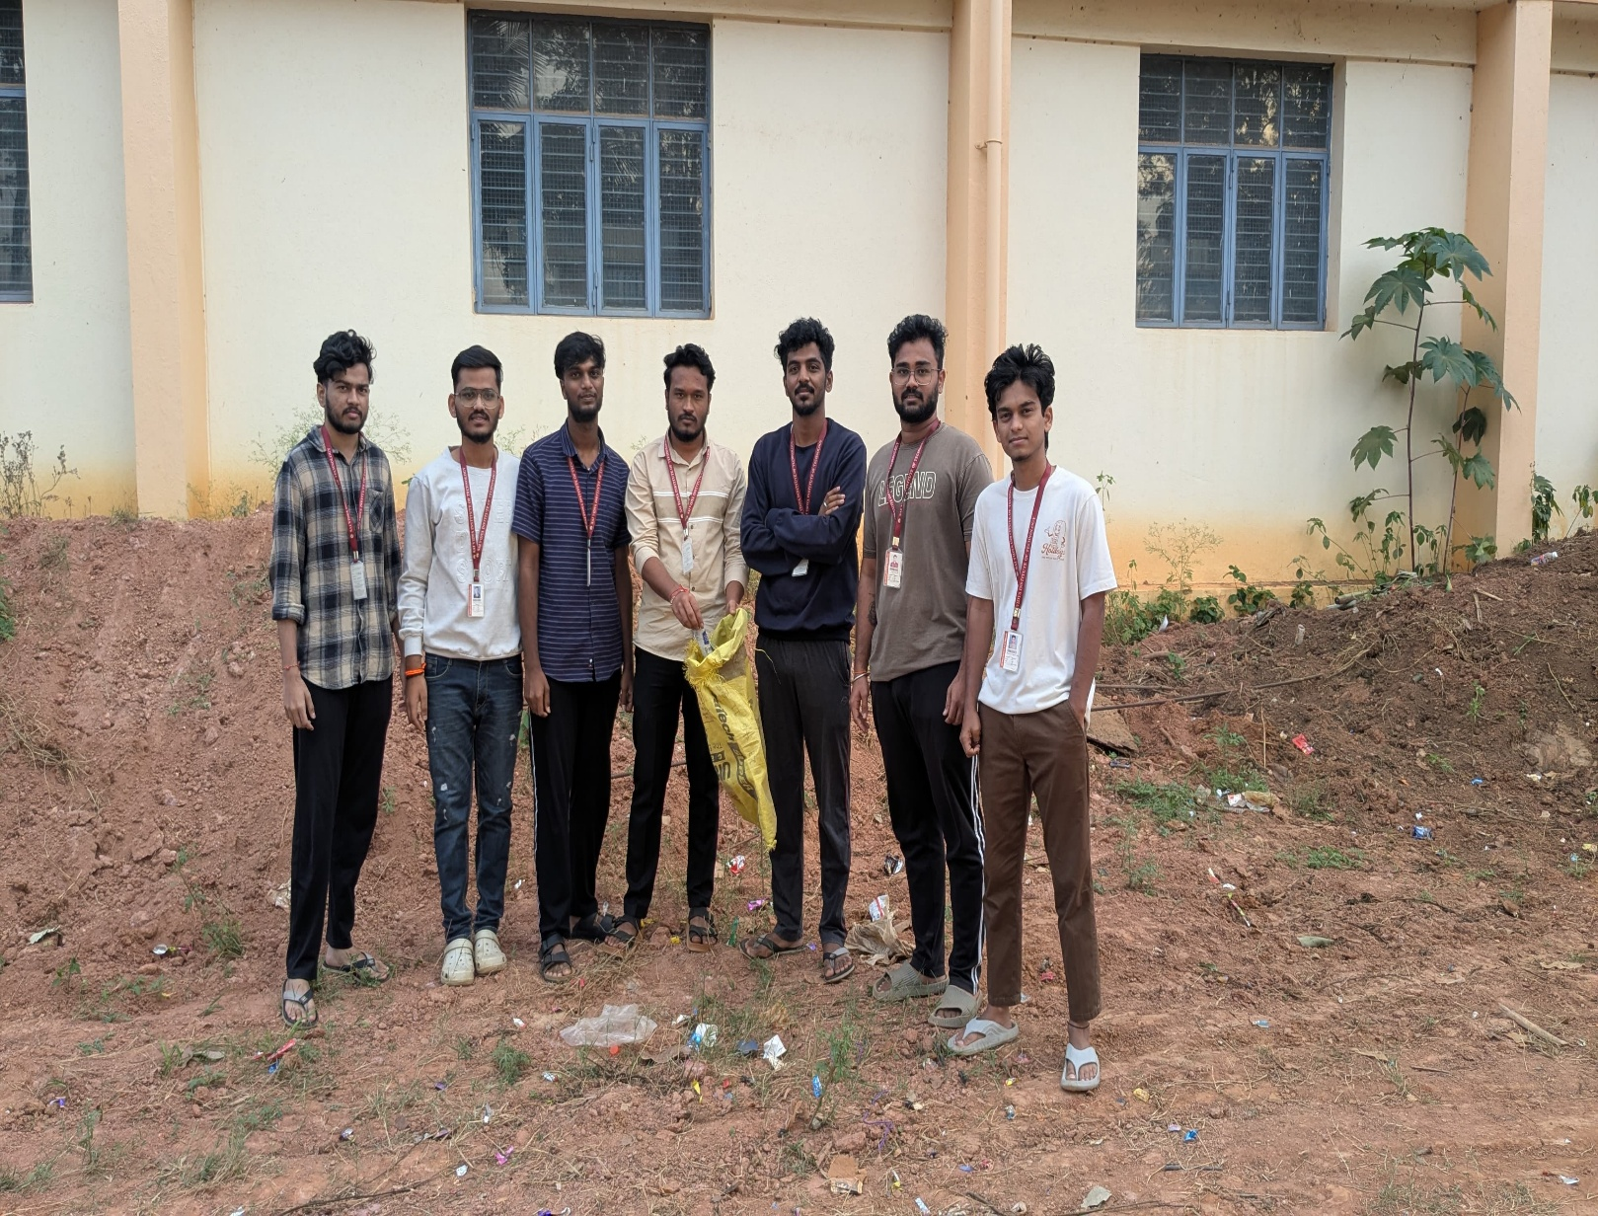

Developing Sustainable Water Management

Objectives
      - To promote the concept of 'Micro-Irrigation' and water conservation by demonstrating efficient watering techniques that minimize surface runoff and evaporation.

      - To implement the principles of "Upcycling" by creatively repurposing discarded plastic waste (PET bottles) into functional engineering utility tools for gardening.

      - To create a sustainable, low-cost, and gravity-fed irrigation system that ensures continuous soil moisture for plants without the need for electricity or manual labor.

Description of the Event
Sustainable water management entails the strategic planning and utilization of water resources to meet current ecological and social needs without compromising the future. In the context of domestic agriculture and gardening, conventional watering methods like flood irrigation or hose spraying are often highly inefficient, leading to significant water loss through rapid evaporation and surface runoff. The solution lies in drip irrigation—a method that delivers water directly to the root zone of the plant in controlled amounts. This approach maintains the ideal soil moisture level, prevents fungal diseases caused by waterlogged foliage, and drastically reduces total water consumption. By integrating this method with the reuse of plastic waste, the initiative addresses two critical environmental challenges simultaneously: mitigating the scarcity of fresh water and finding a functional purpose for non-biodegradable plastic containers, thereby promoting a circular economy model at the household level.
The activity was executed as a decentralized, home-based engineering project, focusing on the design and installation of a DIY drip irrigation system. The raw materials used were exclusively discarded PET (Polyethylene Terephthalate) water and soda bottles, which were cleaned and repurposed. The technical execution involved creating a minute, precision puncture in the bottle cap or base to act as a flow regulator. These bottles were then filled with water and suspended in an inverted position or hung immediately above the root zones of potted plants and garden beds. This setup utilized simple gravity to dispense water drop-by-drop, ensuring deep soil penetration over an extended period. The project successfully demonstrated that

sustainable engineering solutions do not always require expensive infrastructure; rather, simple, innovative applications of waste materials can effectively solve daily resource management problems while keeping the household garden lush and water-efficient.
    - Activity Image
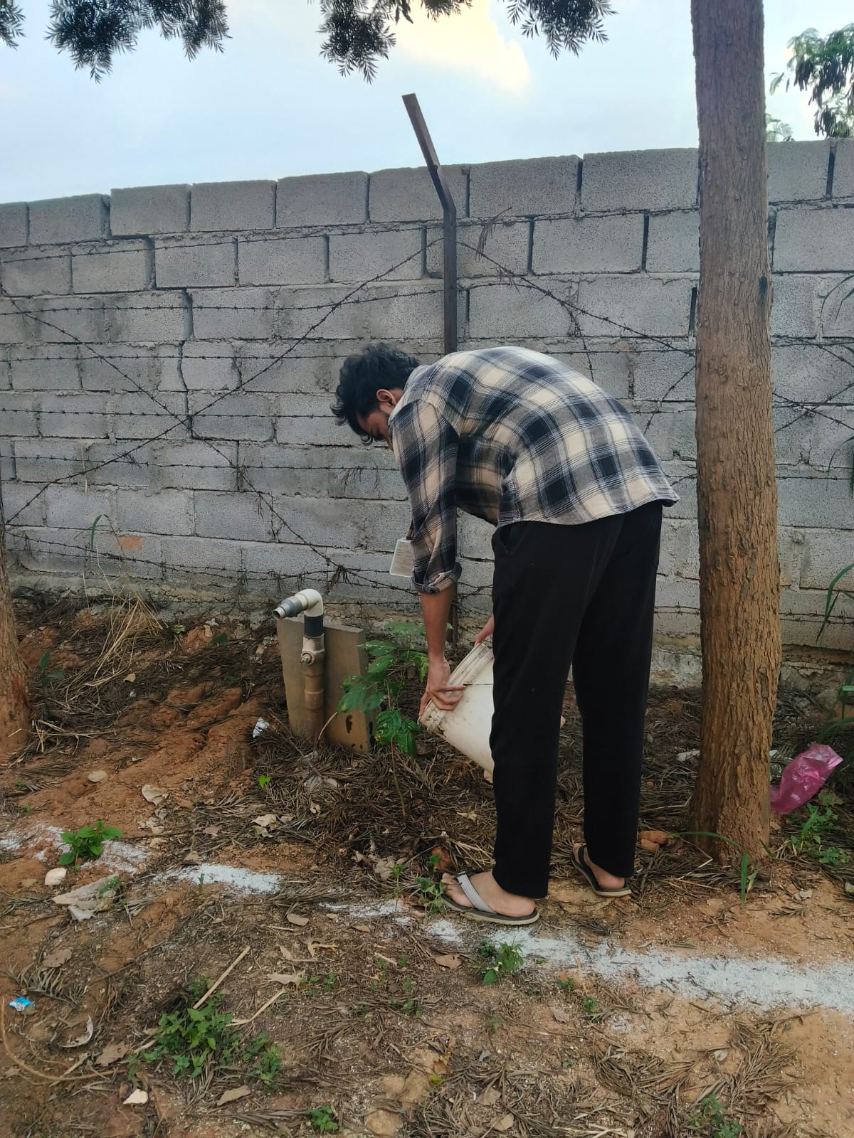

Energy Swaraj – Reduction in Energy Consumption

Objectives
      - To acquire comprehensive "Energy Literacy" through a structured 12-module training program, fostering a deep understanding of energy generation, consumption patterns, and their direct impact on the environment.
      - To implement the "Avoid, Minimize, and Generate" framework within the household to actively reduce the domestic carbon footprint and eliminate energy wastage.
      - To dispel common misconceptions regarding solar energy and adopt behavioral changes that align with the philosophy of "Energy by Locals for Locals," moving towards a carbon-neutral lifestyle.

Description of the Event
The Energy Swaraj movement is a public initiative designed to mitigate climate change by promoting local energy self-reliance. Unlike traditional energy conservation campaigns that focus solely on technology, Energy Swaraj emphasizes "Energy Literacy" as the foundational step for sustainable living. The core philosophy posits that every citizen must understand the carbon cost of their energy usage. The initiative advocates for a three-step approach: first, Avoid the use of energy where possible; second, Minimize the usage of efficient appliances; and third, Generate energy locally, primarily through solar solutions. By decentralizing energy production and consumption, the movement aims to reduce dependence on fossil-fuel-heavy centralized grids, thereby democratizing energy access and significantly lowering greenhouse gas emissions.

This activity was conducted as a hybrid engagement, combining a rigorous online certification course with practical domestic implementation. The theoretical component involved completing the "Energy Literacy Training" provided by the Energy Swaraj Foundation. Spanning 12 comprehensive modules, the course covered critical topics including the quantification of carbon footprints, the environmental cost of energy wastage, and the technical viability of solar alternatives. Following the certification, the principles learned were executed at home through a "Home Energy Audit." This involved cataloging all electrical appliances, calculating their power consumption, and identifying areas of wastage.

National Initiative – Swachh Bharat Abhiyan
    - Objectives
      - To actively contribute to the national vision of a "Clean India" by participating in community-led sanitation drives and waste removal campaigns.

      - To collaborate with local municipal bodies, specifically the Bruhat Bengaluru Mahanagara Palike (BBMP), to understand the logistical challenges of urban civic maintenance.

      - To reinforce the importance of sustained civic engagement by revisiting previously cleaned sites, ensuring long-term maintenance rather than temporary solutions.

Description of the Event
The Swachh Bharat Abhiyan (Clean India Mission) is a massive mass movement launched by the Government of India to realize Mahatma Gandhi’s dream of a clean and hygienic nation. It goes beyond the mere act of cleaning; it is a behavioral change campaign designed to instill a sense of pride in one's surroundings and to eliminate the unhealthy practice of open littering. The initiative emphasizes that cleanliness is not solely the responsibility of sanitation workers but a fundamental duty of every citizen. By engaging youth in this mission, the program aims to create a ripple effect, where students act as ambassadors of hygiene, encouraging their communities to adopt better waste disposal habits and respect public infrastructure. The mission acknowledges that public health, dignity, and economic productivity are intrinsically linked to the sanitation standards of the country.
The implementation of this initiative was conducted in two distinct phases to maximize impact across different urban zones. The first phase took place in Yelahanka in 2024, where student volunteers partnered with the Bruhat Bengaluru Mahanagara Palike (BBMP). The focus was the Major Sandeep Unnikrishnan Road, a vital arterial route. Working alongside municipal workers, students cleared roadside debris, removed illegal posters, and swept pedestrian pathways, gaining a firsthand appreciation for the magnitude of labor required to keep city streets clean. The second phase involved a return to the public parks of Indiranagar. This

follow-up drive was critical as it emphasized consistency; students removed litter that had accumulated since the previous intervention and engaged with park visitors to advocate for maintaining the cleanliness of the shared space. This dual-location approach highlighted the need for both large-scale collaboration with authorities and sustained, localized community efforts.
    - Activity Images

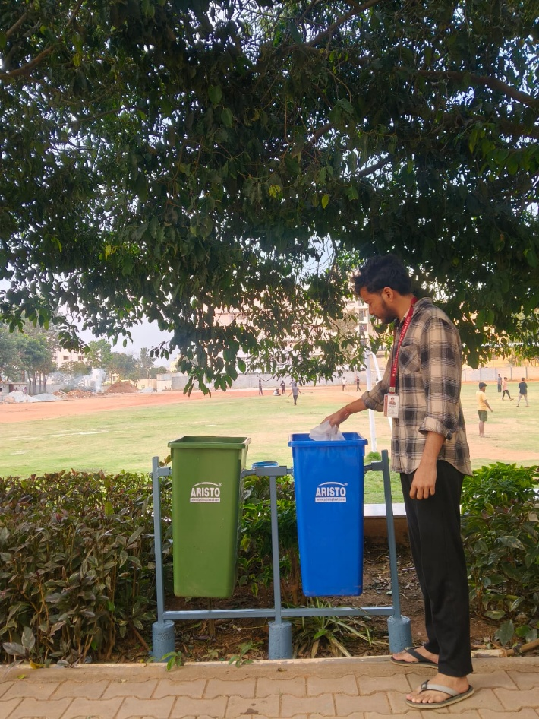

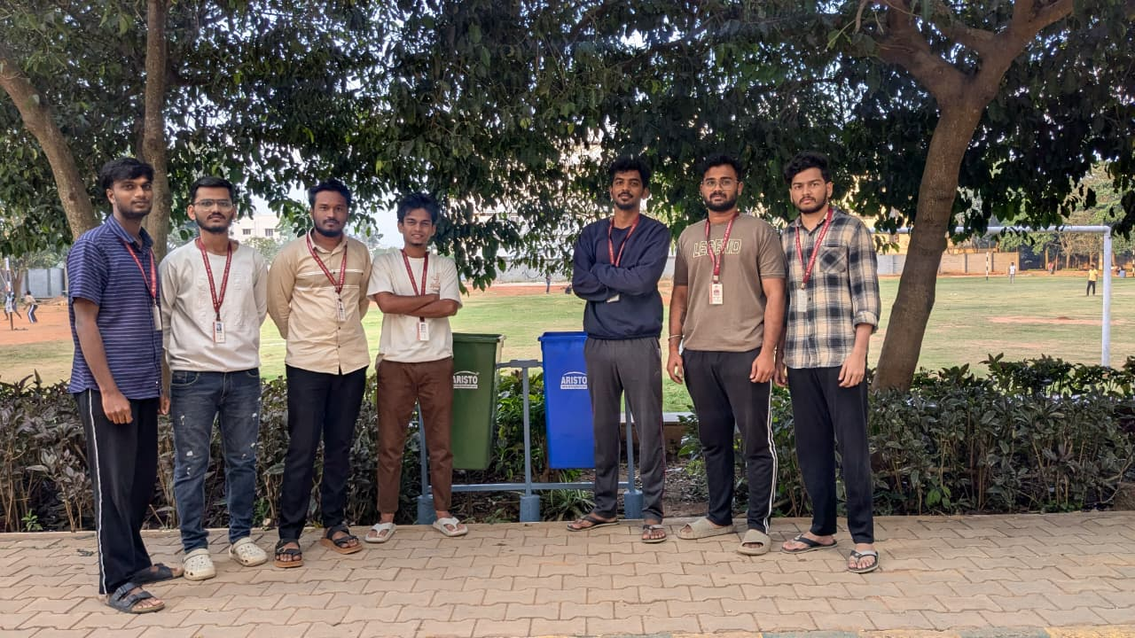

Chapter 3

CERTIFICATES
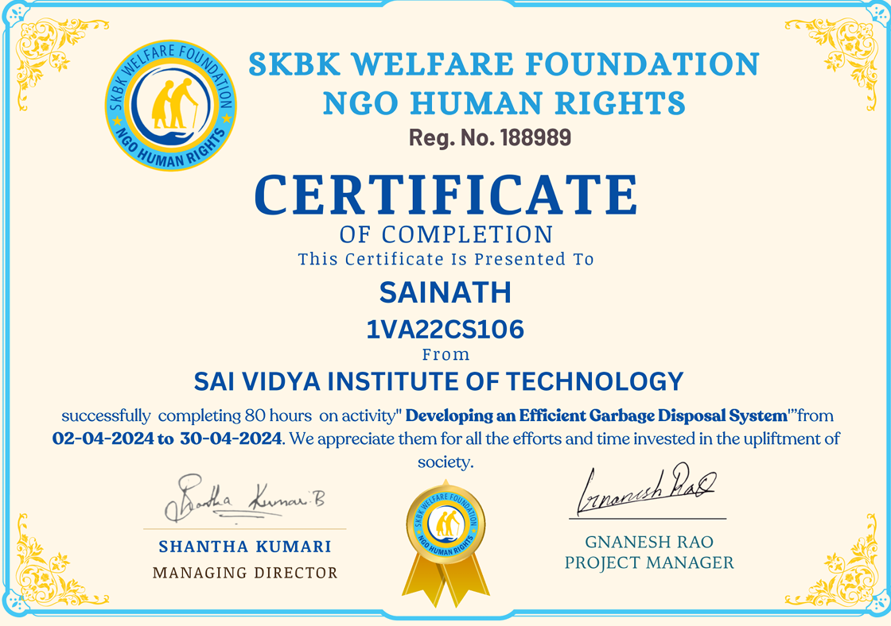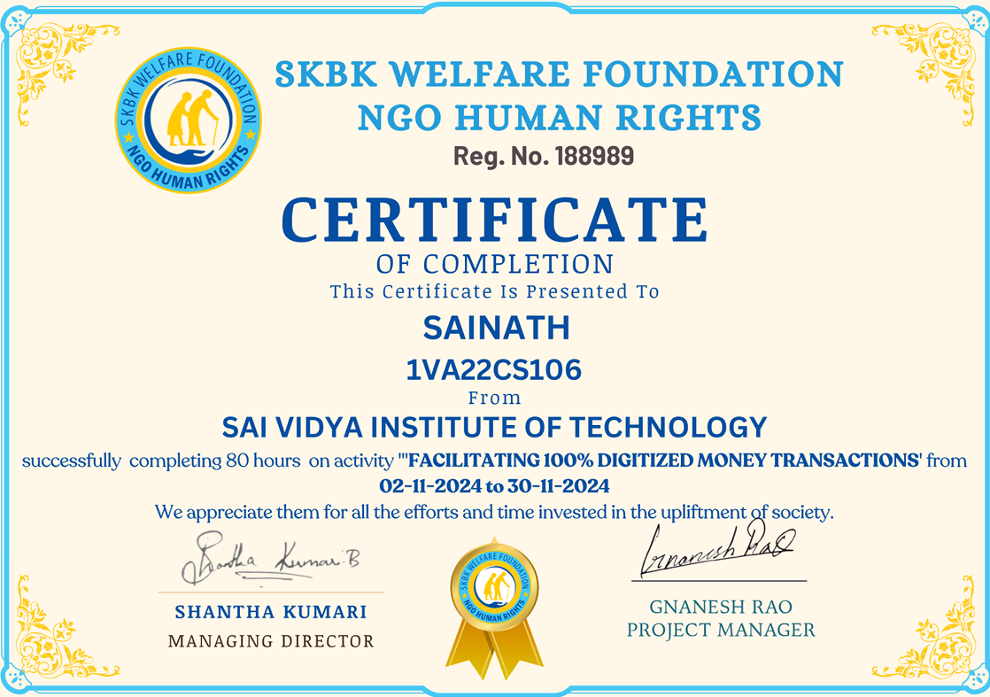

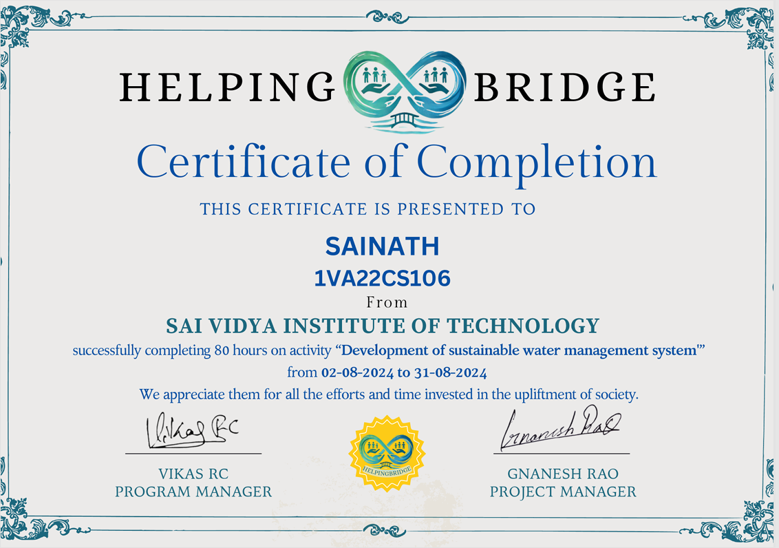

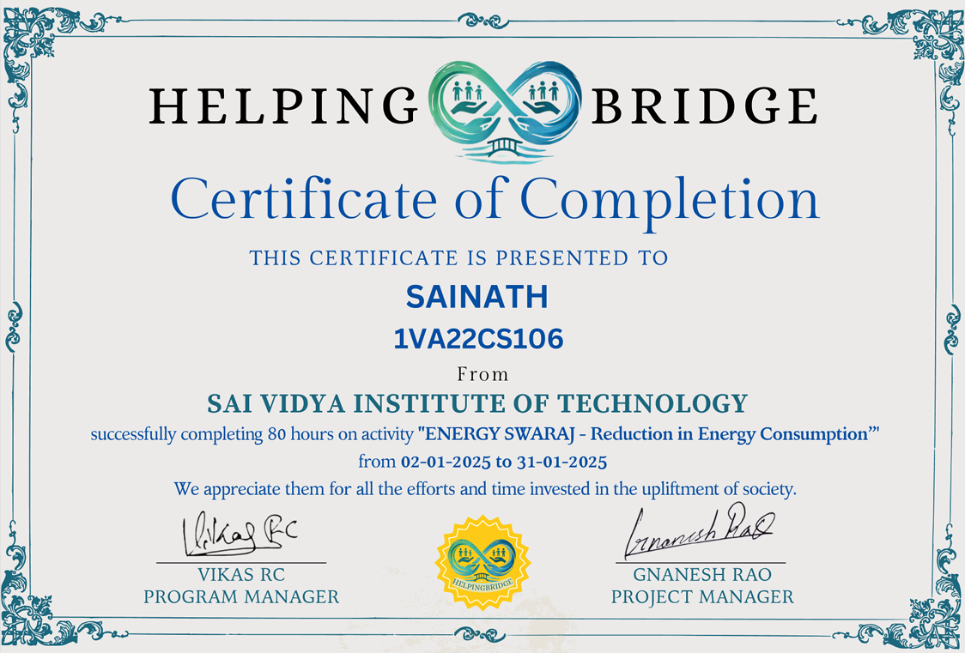

Chapter 4

CONCLUSION

The preceding analyses of Digitization of India, Developing an Efficient Garbage Disposal System, Developing a Sustainable Water Management System, Energy Swaraj, and the National Initiative Swachh Bharat Abhiyan (SBA) reveal a powerful, common conclusion: the successful pursuit of both societal and economic goals in the 21st century relies on the strategic integration of technical intervention, resource optimization, and collective behavioral change to achieve long-term sustainability.
Across all domains, the transition from passive consumption to active conservation is non- negotiable. Whether it is shifting domestic habits through Energy Swaraj to achieve carbon neutrality, implementing Sustainable Water Management techniques for resource security, or institutionalizing Efficient Garbage Disposal systems to promote a circular economy, the core imperative is sustainability. These environmental efforts are inseparable from social well- being, as demonstrated by the Swachh Bharat Abhiyan’s focus on public health and dignity through sustained sanitation habits. This commitment to long-term ecological value, rather than short-term convenience, is the essential unifying principle.
The execution of these diverse programs is consistently enabled by technological integration and systematic analysis. Digitization of India perfectly illustrates how financial technology can bridge economic divides, creating a transparent and inclusive economy. This principle of "engineering for impact" scales to the environmental missions: Energy Swaraj relies on data- driven audits to quantify and reduce carbon footprints; Sustainable Water Management utilizes gravity-fed engineering principles for efficiency; and Garbage Disposal systems depend on the systematic categorization of materials for recycling viability. Technology and logic provide the scalability and precision necessary to measure impact, optimize resource allocation, and ensure accountability across all five areas.
Ultimately, however, no objective is achievable without active community participation and sustained behavioral change. The goals of sanitation (SBA), environmental stewardship (Garbage Disposal), and resource management (Water & Energy) are dependent on individual pledges and ongoing actions.

